AM,C-Taino-Cemi-Maquetaurie Guayaba- Lord of the Dwelling Place of the Dead

Cemi, possibly of Maquetaurie Guayaba- Lord of the Dwelling Place of the Dead made of andesite from the Dominican Republic.

According to Fray Pané, the Taino “believe there is a place where the dead go, which is called Coaybay, and it is located on one side of the island called Soraya. They say that the first person in Coaybay was one who was called Maquetaurie Guayaba (Makitori-Guarana.), who was the lord of the said Coayabay, house and dwelling place of the dead (Pané, ch. 12, 1999: 17-18). José Juan Arrom suggests Maquetaurie may be translated “without life” (ma being a negation and quetaurie “life”) and Guayaba may be translated as the fruit from the tropical tree *Psidium paniferum*. The face of the first person in Coaybay was one who was called Maquetaurie Guayaba. Because he is the Lord of the Dark recesses such as cave or of the dark forest he has wide eyes and a mouth usually without lips, and no navel, which signified him being of the nether regions and death (Arrom in Pané 1999: 18, n. 80, n. 81).

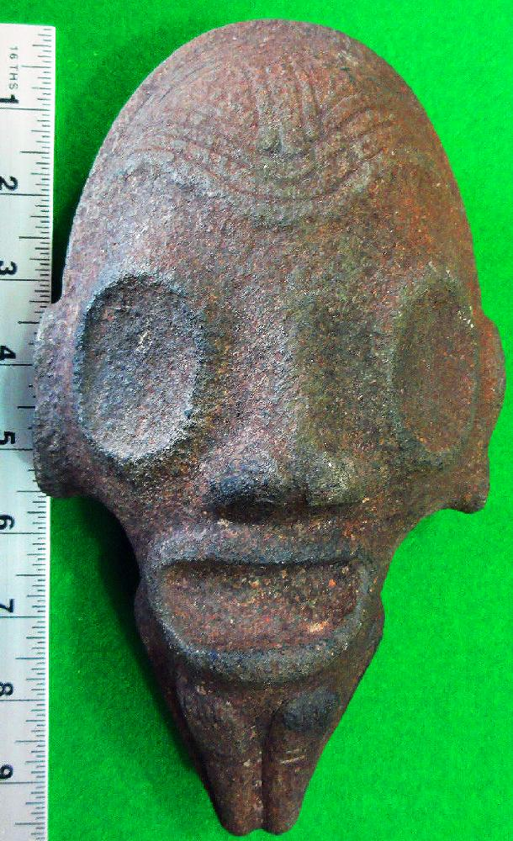

References

Pané, Fray Ramon. 1999. *An account of the antiquities of the Indians*. A new edition, with introductory study, notes, & appendices by José Juan Arrom. Translated by Susan C. Griswold. Durham and London: Duke University Press.